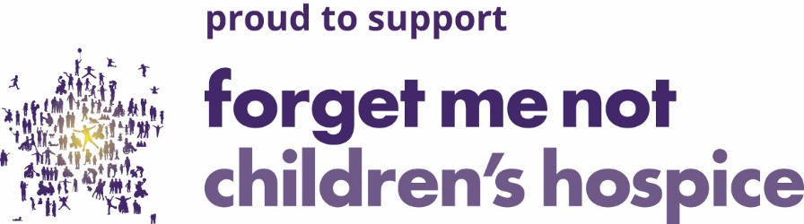

Holmfirth Town U14s are delighted to announce their support for The Forget Me Not Children’s Hospice.
Due to a kind sponsorship donation to supply the boys with a brand new away kit, our U14s (next seasons U15s) will display the charity logo on the new shirt over the next two seasons offering publicity for an excellent charity both on the shirt and via our website which will also include a link to the charity web page www.forgetmenotchild.co.uk where you can discover more about the charity’s work and how you can help.
Forget Me Not share many of our own core values here at Holmfirth Town with strong links to the local community and Children’s health.
Please visit the link to discover what this incredible charity and their wonderful staff do for the parents and carers of children in our area with life-shortening conditions from as early as pregnancy onwards, it is truly inspiring.
Forget me not needs £4 million per year to do their amazing work and are hugely dependent on generous donations and fundraising support. There are many innovative ways to donate and offer help including playing the lottery for £1 per week with a chance to win up to £10,000. Legacy donations, in memory donations, Celebration wall, fundraising as a group or business plus donations to shops or helping out as a volunteer.
This year the Charity celebrates 10 years of helping provide vital support for local families in desperate need and in true Forget Me Not tradition they are offering the innovative and somewhat adventurous opportunity to Fire up your weekend on the 5th June with a sizzling 10th birthday special event, the Forget Me Not Fire Walk! (See link)
www.forgetmenotchild.co.uk/supporting-us/events/detail/2021/06/05/default-calendar/firewalk-lego-walk

